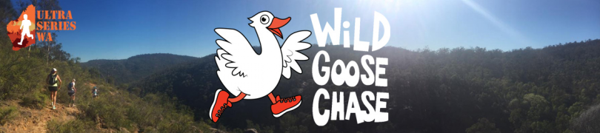

Wild Goose Running Festival

19-21 May, 2017

All events start and finish at the Homestead campground.
All maps shown are orientated with North as up.
Limited vehicle access to Homestead campground for competitors. Majority of competitor parking will be at the old airfield on Quarry Rd.

19km Event

Course map

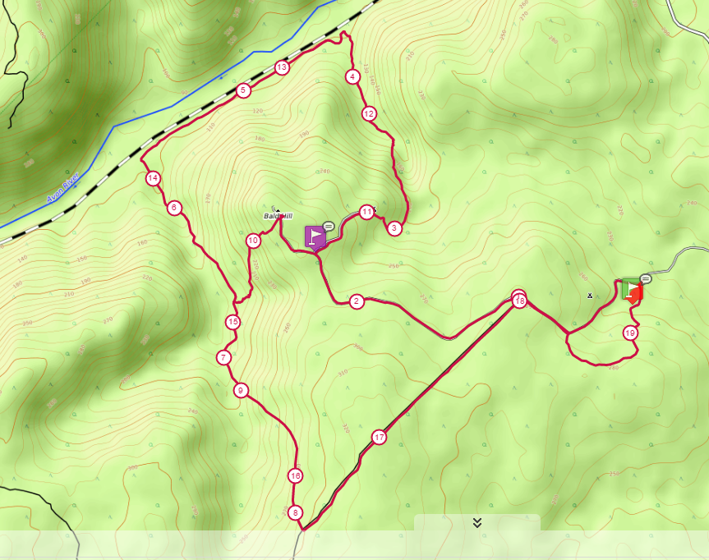

Profile

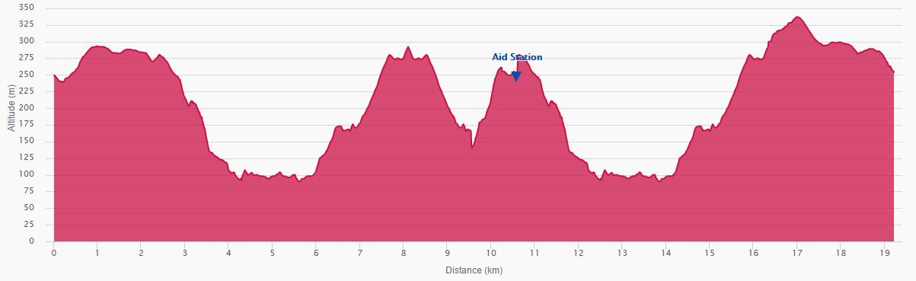

Aid Station Details (19.2km)
Location | Total Distance | Distance to next
Start | 0 km | 10.6 km
Aid Station | 10.6 km | 8.6 km
Finish | 19.2 km

22km Event

Course map

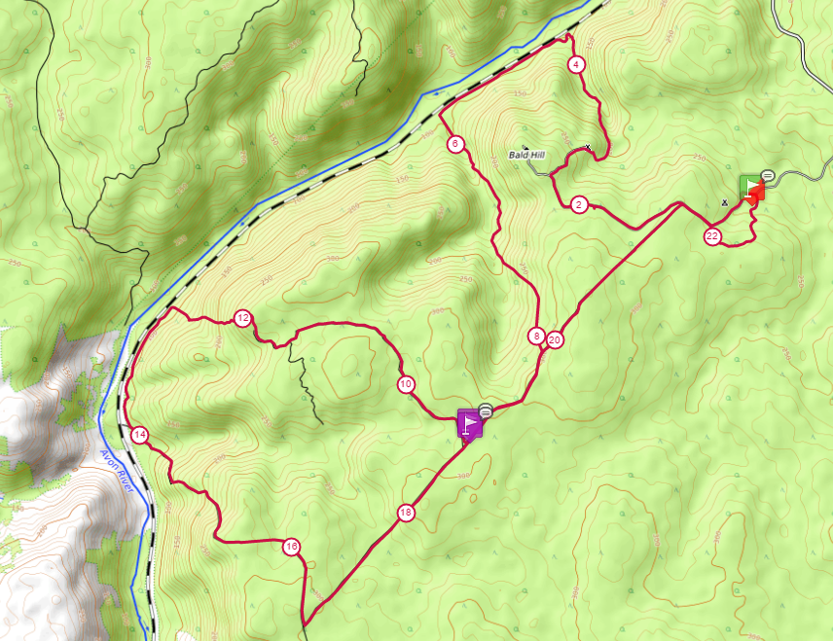

Course Profile
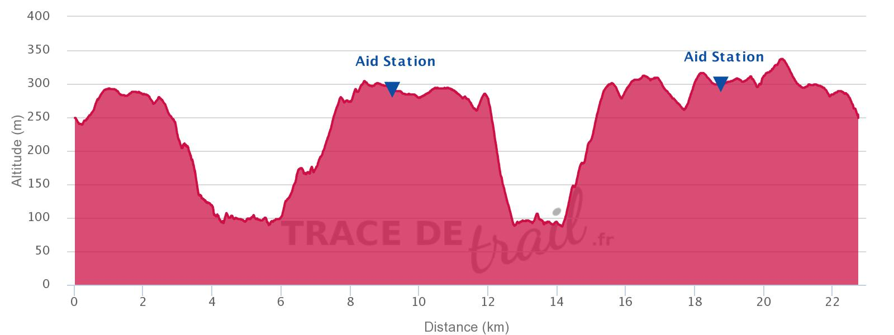

Aid Station Details (22km)
Location | Total Distance | Distance to next
Start | 0 km | 9.2 km
Aid Station | 9.2 km | 9.6 km
Aid Station | 18.8 km | 3.9 km
Finish | 22.7 km

45km Event

Course map

Course Profile
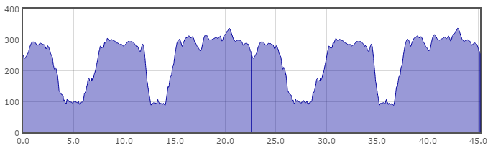

Aid Station Details (45km)
Location | Total Distance | Distance to next
Start | 0 km | 9.2 km
Aid Station | 9.2 km | 9.6 km
Aid Station | 18.8 km | 3.9 km
Village Aid station | 22.7 km | 9.2 km
Aid Station | 31.9 km | 9.6 km
Aid Station | 41.5 km | 3.9 km
Finish | 45.4 km

53km Course

Course Map
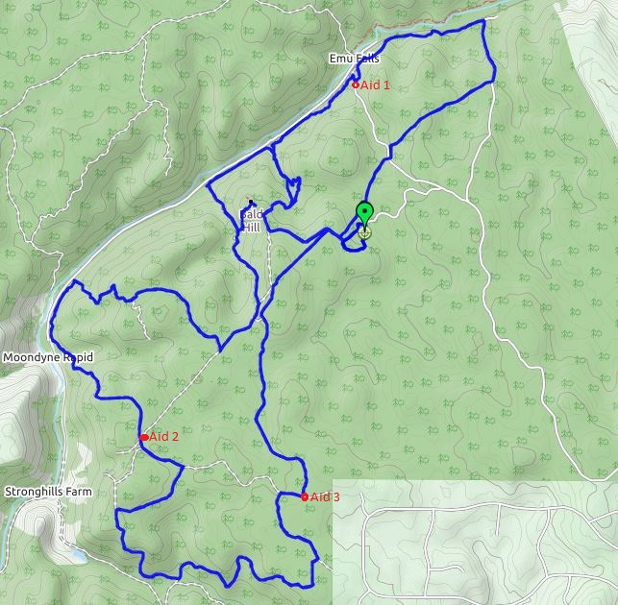

Course Profile (53km)
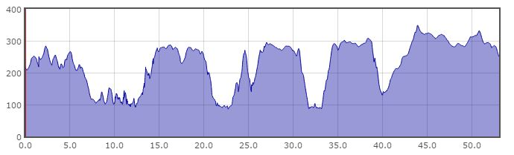

Aid Stations (53km)
Location | Total Distance | Distance to next
Start | 0 km | 10.1 km
Aid Station 1 | 10.1 km | 7.3 km
Village Aid Station | 17.4 km | 18.6 km
Aid Station 2 | 36.0 km | 10.3 km
Aid Station 3 | 46.3 km | 6.9 km
Finish | 53.2 km

106km Course

Course Map

Course Profile
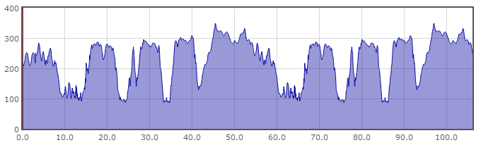

Aid Stations (106km)
Location | Total Distance | Distance to next
Start | 0 km | 11.6 km
Aid Station 1 | 11.6 km | 7.3 km
Village Aid Station | 18.9 km | 18.6 km
Aid Station 2 | 37.5 km | 10.3 km
Aid Station 3 | 47.8 km | 6.9 km
Village Aid Station | 54.7 km | 8.6 km
Aid Station 1 | 63.2 km | 7.3 km
Village Aid Station | 70.5 km | 18.6 km
Aid Station 2 | 89.1 km | 10.3 km
Aid Station 3 | 99.4 km | 6.9 km
Finish | 106.1 km | 8.6 km

